Travel information

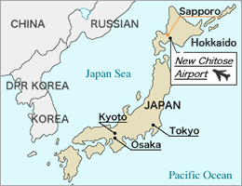
Osaka (Kansai) International Airport
Tokyo (Narita) International Airport

1.3 hrs 2 hrs

Sapporo (New Chitose Airport)

36 min. by JR(Japan Railway)
New Chitose Airport – Sapporo
by Rapid Airport Express. 36 min. (fastest)/ JPY1,040 (one way)

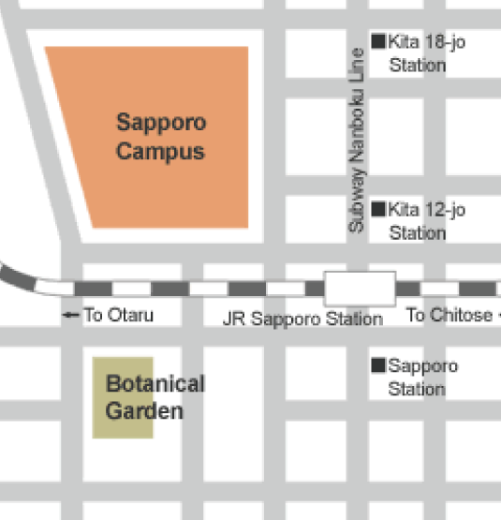
(New Chitose Airport Terminal)
Time table from New Chitose Airport to Sapporo Station http://www.new-chitose-airport.jp/en/access/jr/timejr/
JR Sapporo Station

2 mins. by walk
Sapporo Aspen Hotel
15 mins. by walk
Venue: Hokkaido University, Graduate School of Veterinary Medicine
Accommodation in Sapporo
Sapporo Aspen Hotel
Address/ Kita 8-jyo Nishi 4-chome, Kita-ku, Sapporo
Phone /011-700-2111
http://www.aspen-hotel.co.jp/english/frame.htm
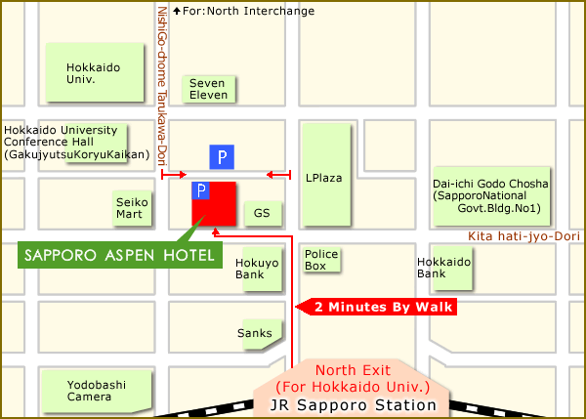

Information of Sapporo and its climate is available on the following sites:
http://www.hokudai.ac.jp/en/pickup/usefullinks.html
http://www.welcome.city.sapporo.jp/english/
http://english.wunderground.com/global/stations/47412.html+weather,+Sapporo&hl=ja
How to get your hotel in Sapporo from New Chitose Airport (Sapporo)

Your accommodation in Sapporo

Sapporo Aspen Hotel
Address/ 5, Kita8-jyo Nishi4-chome, Kita-ku, Sapporo, Hokkaido 060-0808 Japan

Phone / Fax Phone 011-700-2111 / FAX 011-700-2002
http://www.aspen-hotel.co.jp/english/frame.htm

1. Please get JR train from the airport to Sapporo station
From New Chitose Airport
(The station is located on B1F) http://www.new-chitose-airport.jp/en/tmap/
to Sapporo by Rapid Airport Express. 15-min. intervals, 36 min. (fastest),
Fare (one way): Adult 1,040JPY
http://new-chitose-airport.jp/en/access/jr/
Time table in English
http://new-chitose-airport.jp/en/access/jr/timejr/
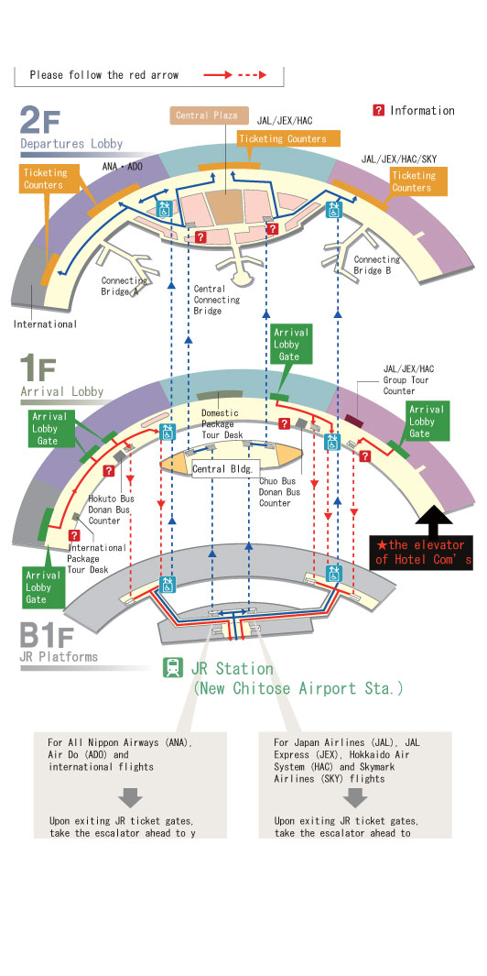
↓New Chitose Airport

2. From Sapporo station (North Exit) to the hotel is 2 minutes by walk

JR Sapporo Station layout
http://www2.jrhokkaido.co.jp/global/english/access/sapporo.html

Emergency contact
Contact mobile No. during weekend and night
Maki’s Mobile 090-6267-1550, makiyukisnow@softbank.ne.jp

FYI

Hokkaido University Campus
http://www.hokudai.ac.jp/en/pickup/accesstocampus.html

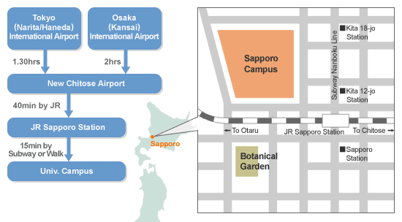

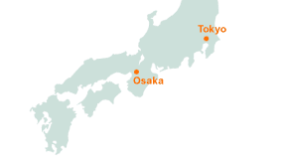

Sapporo city
http://www.welcome.city.sapporo.jp/english/index.html
Narita International Airport (Tokyo)
http://www.narita-airport.jp/en/index.html

Weather in December in Sapporo
The snowy season starts in earnest as it begins to snow almost every day.
Average temperate: -0.9, low -4.1, high 2.1
Time table of
JR train New Chitose Airport
–Sapporo
(Updated by March 12, 2011)

“R” as rapid train on the time table

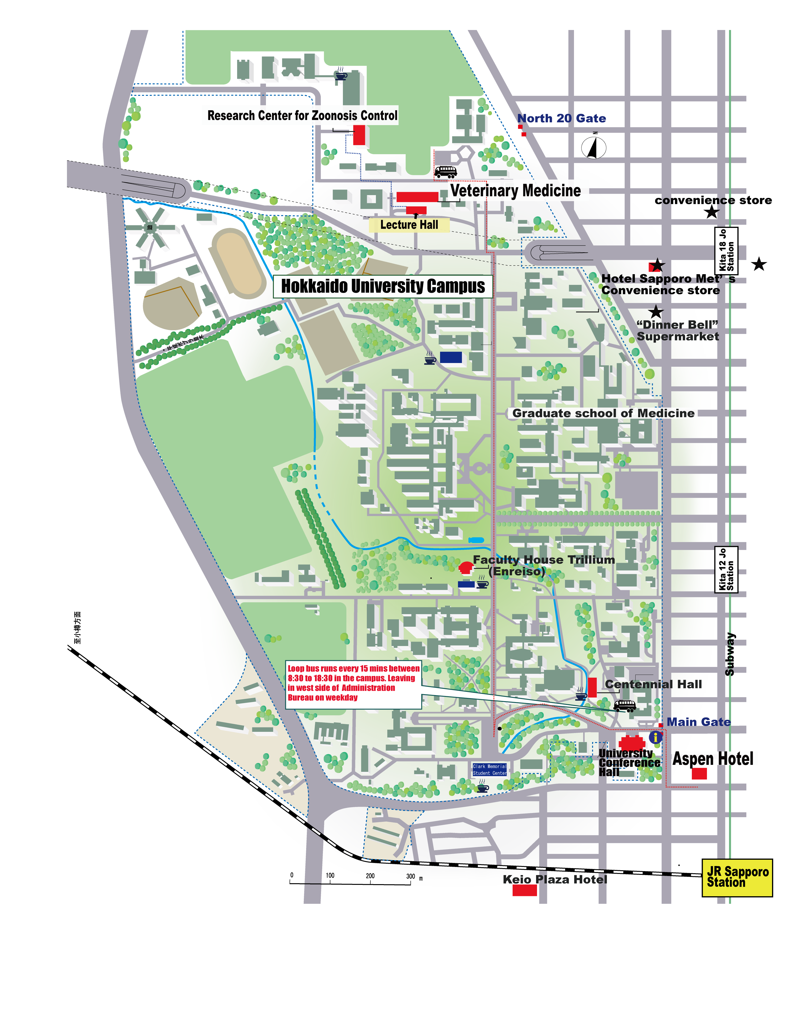
Hokkaido University Campus

Regional forum of collaborating/reference centres on emerging infectious diseases and zoonoses, 5 to 6 December 2011, Sapporo Japan

Venue: Conference Hall
Conference room
Graduate School of Veterinary Medicine
Address/ Kita 18-jyo Nishi 9-chome, Kita-ku, Sapporo, 060-0818, Japan
http://www.vetmed.hokudai.ac.jp/gcoe/english/event.html
gcoe@vetmed.hokudai.ac.jp
Tel. & Fax.: 0081-11-706-5294

